**KUMARAGURU COLLEGE OF TECHNOLOGY**

**Software Engineering**

**Project Report**

# KCT Friendly App

Version 1.0.1

Prepared by

Group Name: br0k3n_h4nd5

|  |  |  |
| --- | --- | --- |
| NANDHAKUMAR K | 18BIS015 | nandhakumar.18is@kct.ac.in |
| NARENDRAKUMAR G S | 18BIS003 | narendrakumar.18is@kct.ac.in |
| GOKULAKRISHNAN R | 18BIS012 | gokulakrishnan.18is@kct.ac.in |
| NAVEENKUMAR M | 18BIS026 | naveenkumar.18is@kct.ac.in |
| HARIHARAN A V | 18BIS007 | hariharan.18is@kct.ac.in |
|  |  |  |

*Submitted on: 17-05 2020*

Table of Contents

Revision History

1. Introduction

1.1 Purpose

1.2 Document Conventions

1.3 Intended Audience and Reading Suggestions

1.4 Product Scope

1.5 References

2. Abstract

3. Hardware and Software requirements

3.1 Performance Requirements

3.2 Safety Requirements

3.3 Security Requirements

3.4 Software Quality Attributes

4. Proposed Methodology

4.1 Product Perspective

4.2 Product Functions

5.UML Diagrams &. Module Description

6.Literature Survey

7.Results and Discussion

9.References

Revision History

|  |  |  |  |
| --- | --- | --- | --- |
| Name | Date | Reason for Changes | Version |
| KCT Friendly App | 20/04/2020 | ---- | 1.0.0 |
| KCT Friendly App | 12/05/2020 | 1.Inclusion of Help section  2.Bug fixes | 1.0.1 |

**1.INTRODUCTION**

1.1 Purpose:

The purpose of this document is to provide a intricate description of the android application “KCT Friendly App”. This document will explain the eventual purpose and salient features of the application, the interfaces, what the application will do and the constraints under which it must operate. This document is intended for users of the application primarily students and also potential developers.

1.2. Document Conventions:

This Document was created based on the IEEE template for System Requirements Specification Documents.

1.3. Intended Audience and Reading Suggestions:

* Primarily for students who want to know their mark to be scored in the semester based on their previous CAT and CAM marks.
* Students who are in need to know the number of classes to be attended to qualify for the approaching assessment.
* Application Developers who needs an idea about the strategy on how this application has been developed systematically.

1.4. Product Scope:

A Student Friendly Application for the betterment of the college students in our college. Simplifying the need to calculate the marks that is need to be scored in the semester exams and showcasing the importance of class attendance and the credits.

1.5. Reference:

1. GitHub Link

<https://github.com/Br0k3nh4nd012>

1. Demo Video

<https://drive.google.com/drive/u/0/folders/1aNScGlgktnhXH1AURP_tosXzkHld-KFJ>

IEEE Template for System Requirement Specification Documents:

<https://goo.gl/nsUFwy>

**2. Abstract:**

* In an educational organization like college, schools the students nowadays are not liable to paper works as they all have a smarty in handy device (mobile) to access everything right from their place. Henceforth we have developed a short project or mobile based application, so called “KCT Friendly App” to predict the mark to be obtained based on the formerly graded assessment marks, and to know the number of classes to be attended in order to qualify for the final semester exam.
* Moreover, we have enclosed our small piece of work, a chatbot to clarify the doubts or remain as a help centre for the students.

**3. Hardware Software and non – functional requirement**

3.1 Performance Requirement

* KCT Friendly App can be accessed on any mobile.

3.2 Safety Requirements

* User Data are handled with high security in order to prevent any type of data breach with a team of highly talented cyber specialist.
* Google firebase is considered to be one of the most trusted backend service providers which we use to store the data. So, safety is guaranteed.

3.3 Security Requirements

* Individual Privileges are given for the different users through different portals.

3.4 Software Quality Attributes

* KCT Friendly App provides the users with basic fundamental features needed for the day-to-day life of KCT college student. Due to its well designed and easy to use interface it can be used by both experts and typical users.

**4. Proposed Methodology:**

4.1. Product Perspective:

* In this page, the login credential of the user is taken.
* The password is verified with the database and the user is given access to further pages.
* Main page contains the access to the 3 basic features of the application. The user has to select one form the options
  + Sem Mark Estimator
  + Attendance Predictor
  + Credits Analyzer
* In Sem Mark Analyzer User is asked to enter the mark of CAT -1, CAT -11 and CAM Assignment Mark respectively.
* As the calculate button is pressed, based on the input provided by the user eligibility mark to be score a certain grade in the semester exam has been calculated and output is provided in the screen itself.
* Attendance Predictor Page - Based on the provided email id in the login page the user is provided with certain attendance details such as
  + Attendance Percentage in each subject in the current semester
  + Is the current percentage eligible to write the Internal or Semester exam?
  + Number of classes needed to attend in the subjects where the attendance result is “NOT ELIGIBLE”.

4.2. Product Functions:

Workspace:

* Faculty update the attendance on daily basis.

Tools:

* Android Studio _ To develop frontend.
* Chatfuel -To develop help centre
* Google firebase- To store the backend data

.

**5. UML Diagrams:**

1. Class diagram:

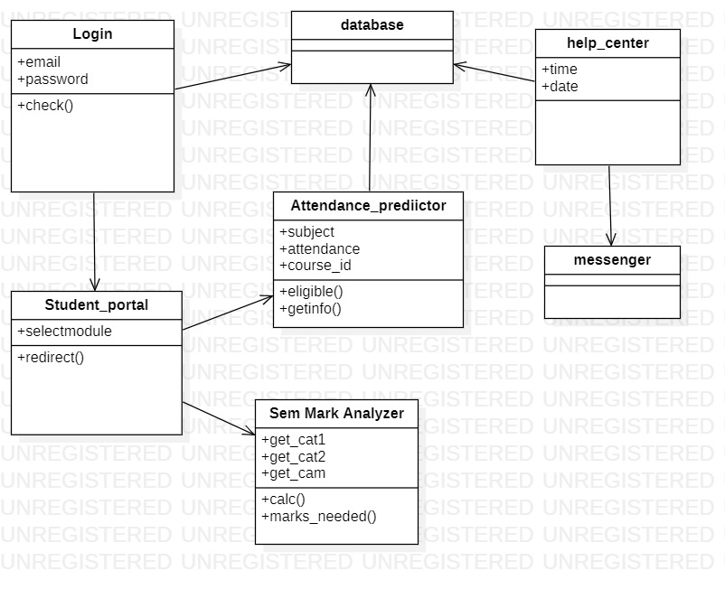

## Purpose of Class Diagrams

1. Shows static structure of classifiers in a system
2. Diagram provides a basic notation for other structure diagrams prescribed by UML
3. Helpful for developers and other team members too
4. Business Analysts can use class diagrams to model systems from a business perspective

2) Use case Diagram:

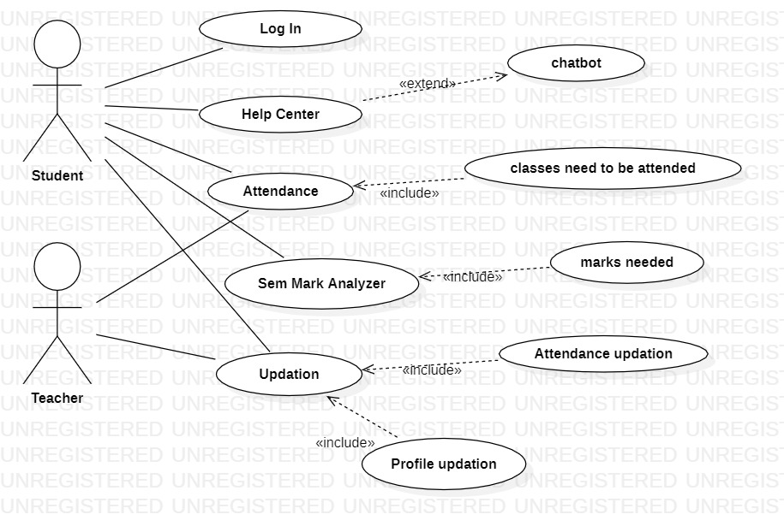

Use case diagram is one of them and its specific purpose is to gather system requirements and **actors**. Use case diagrams specify the events of a system and their flows. But use case diagram never describes how they are implemented.

1. Activity Diagram:

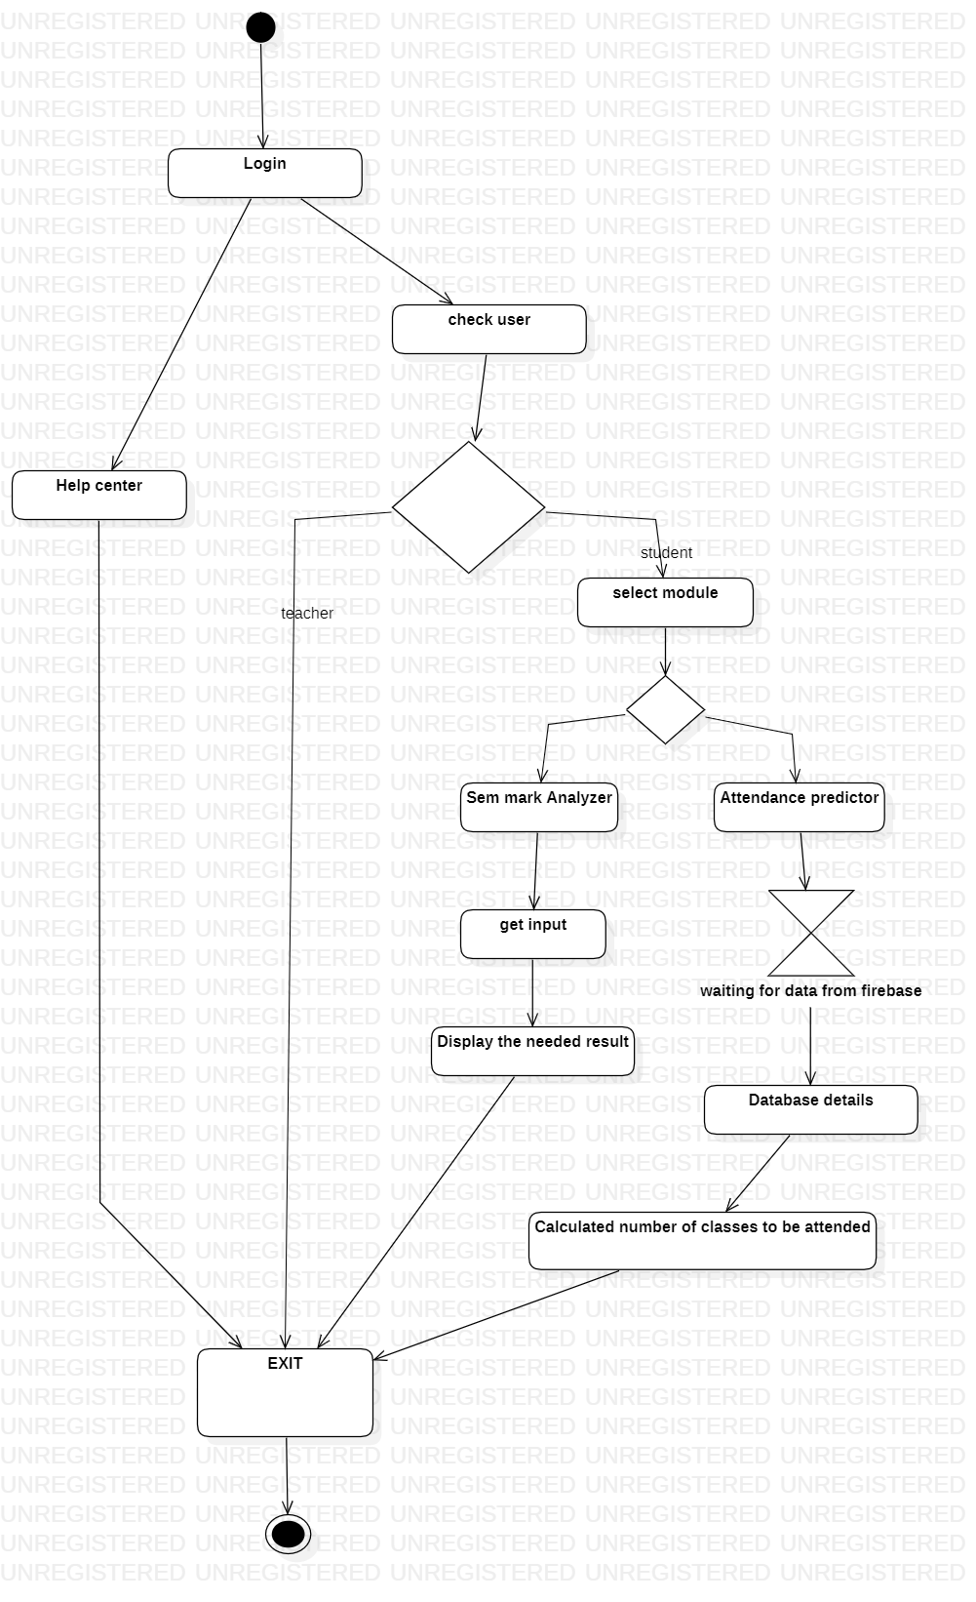

**Activity diagram** is used to show message flow from one **activity** to another.

1. Sequence Diagram:

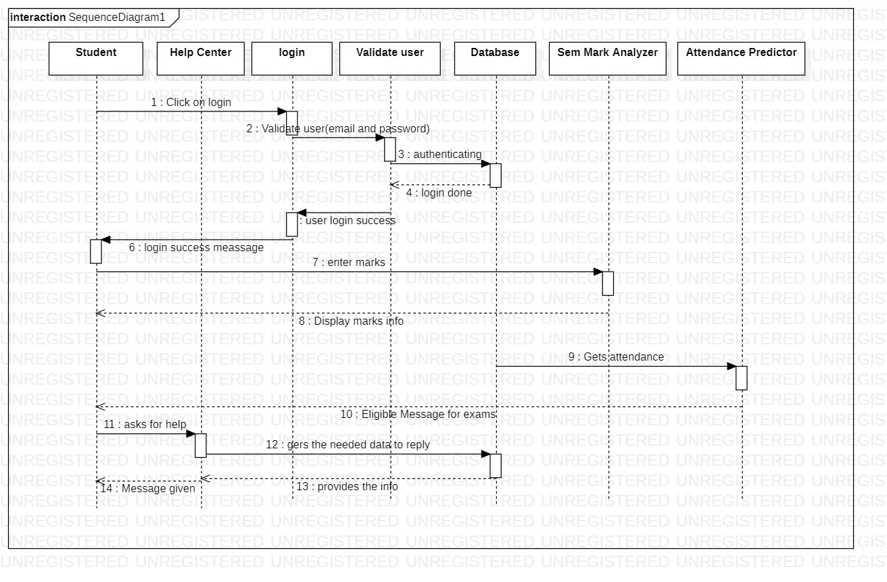

The **sequence diagram** is used primarily to show the interactions between objects in the sequential order that those interactions occur.

Backend Database View:

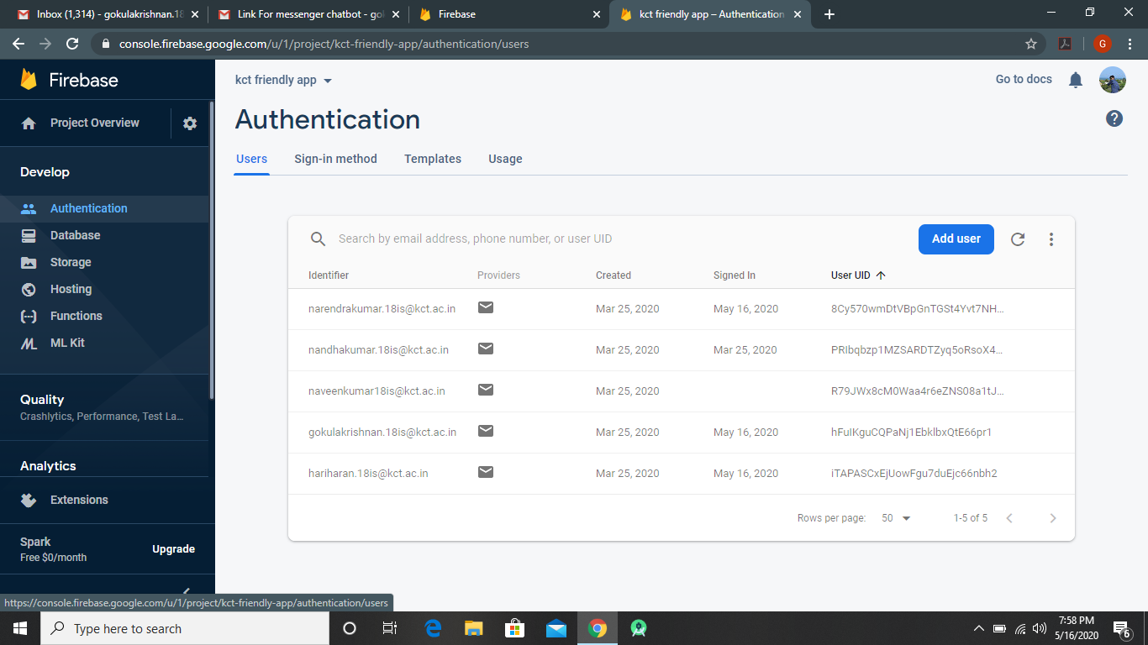

Figure 1 : Login Authentication Database

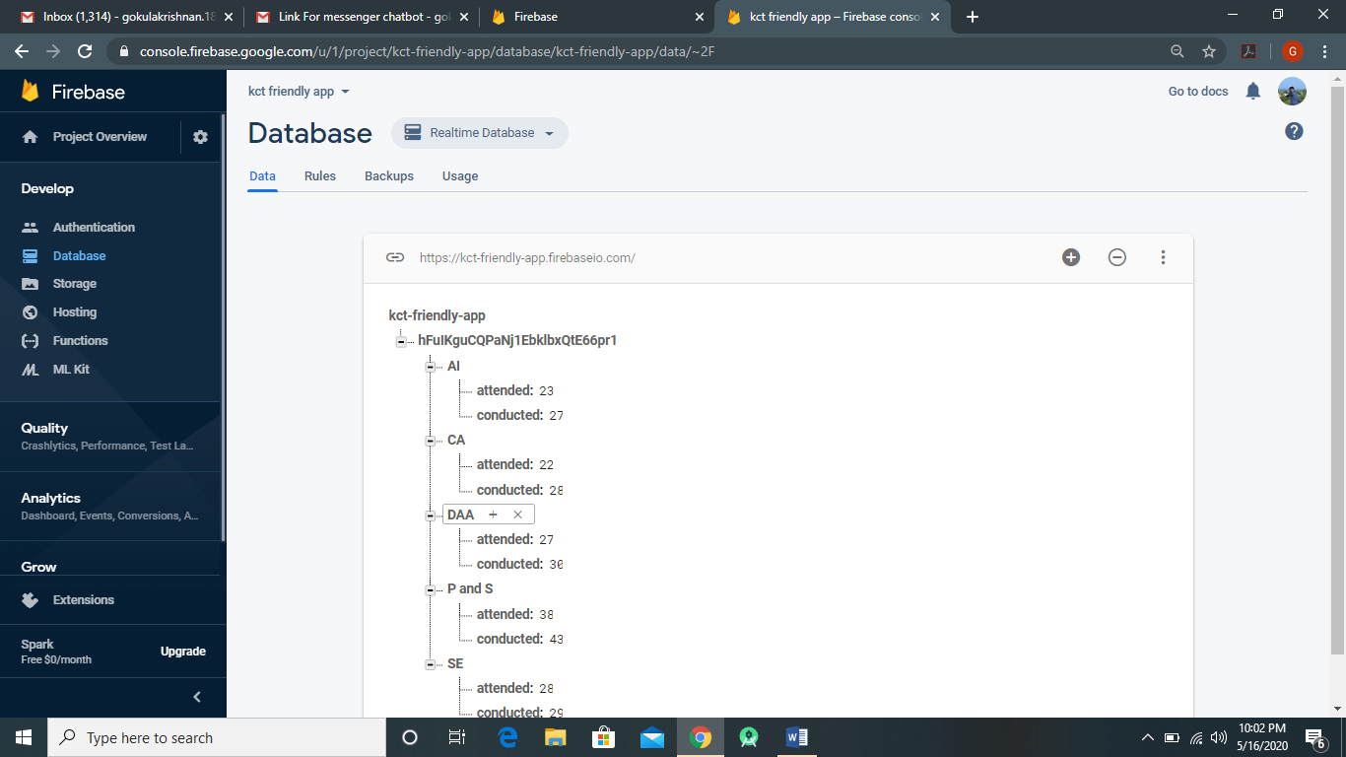

Figure 2 : Real time database Attendance Predictor (similar for all users)

**Module Description:**

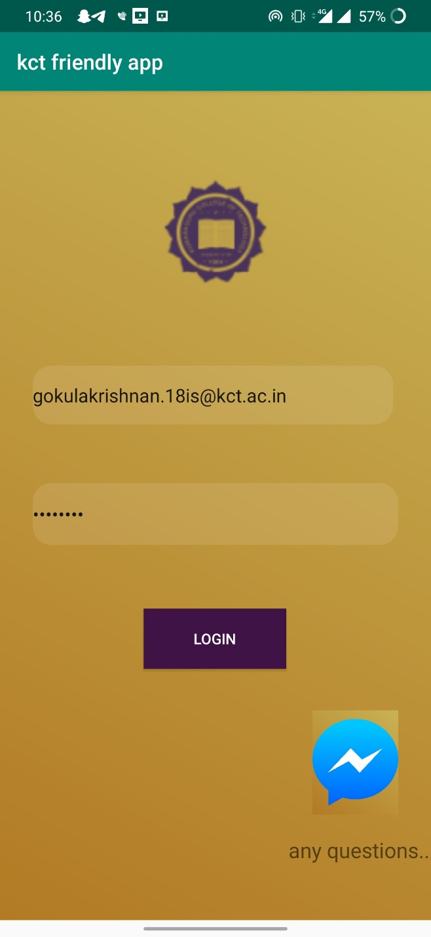

Figure 3 : Login Page

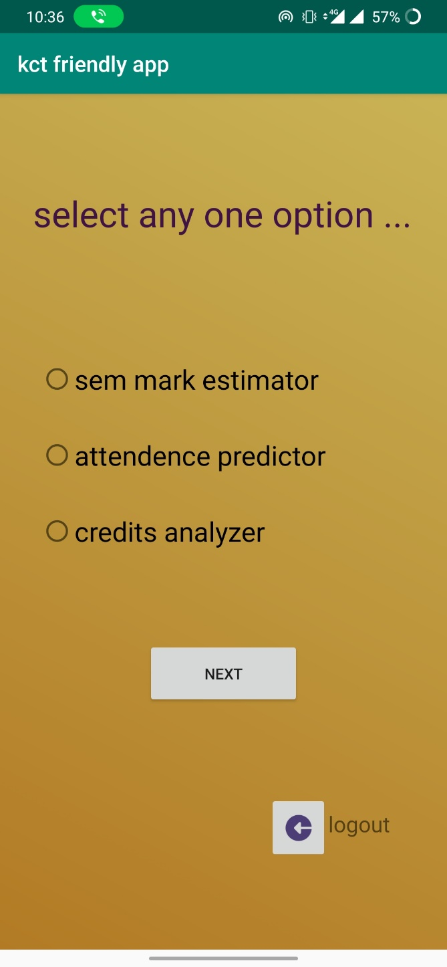

Figure 4 : Main Portal

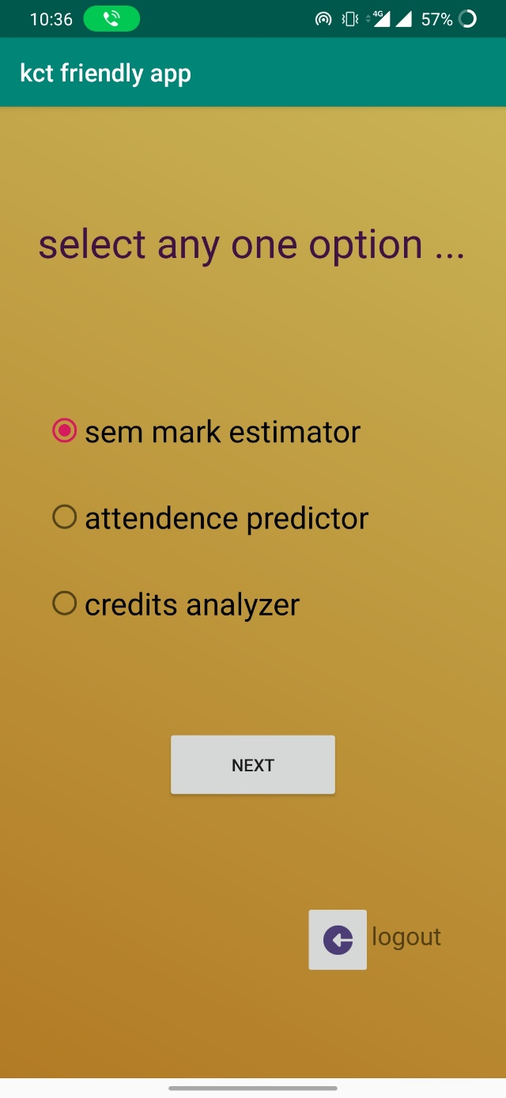

Figure 5 : Selection of required action

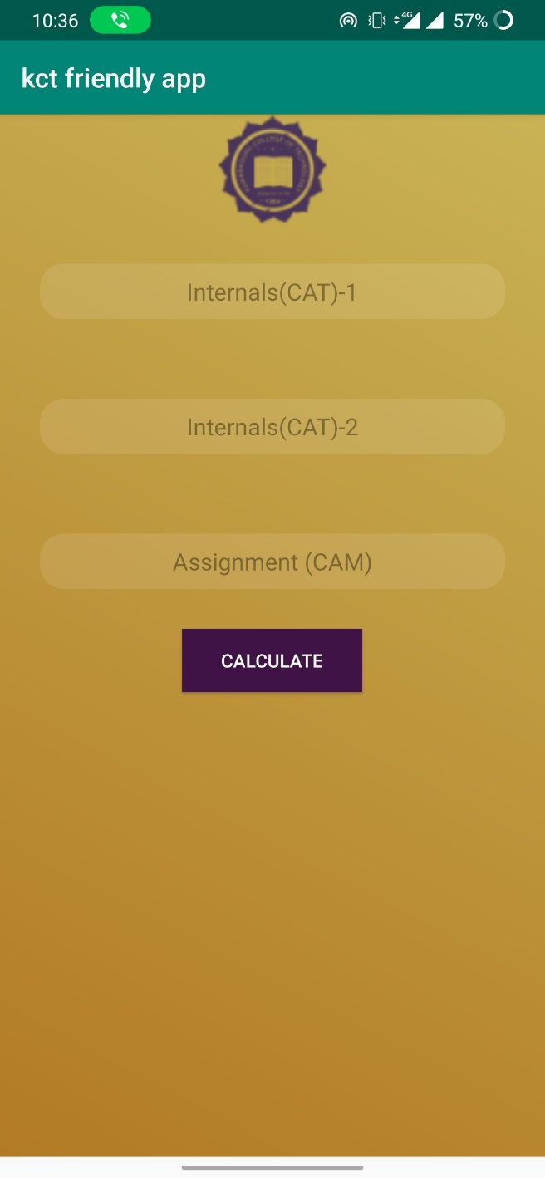

Figure 6.1: Mark Analyzer Portal

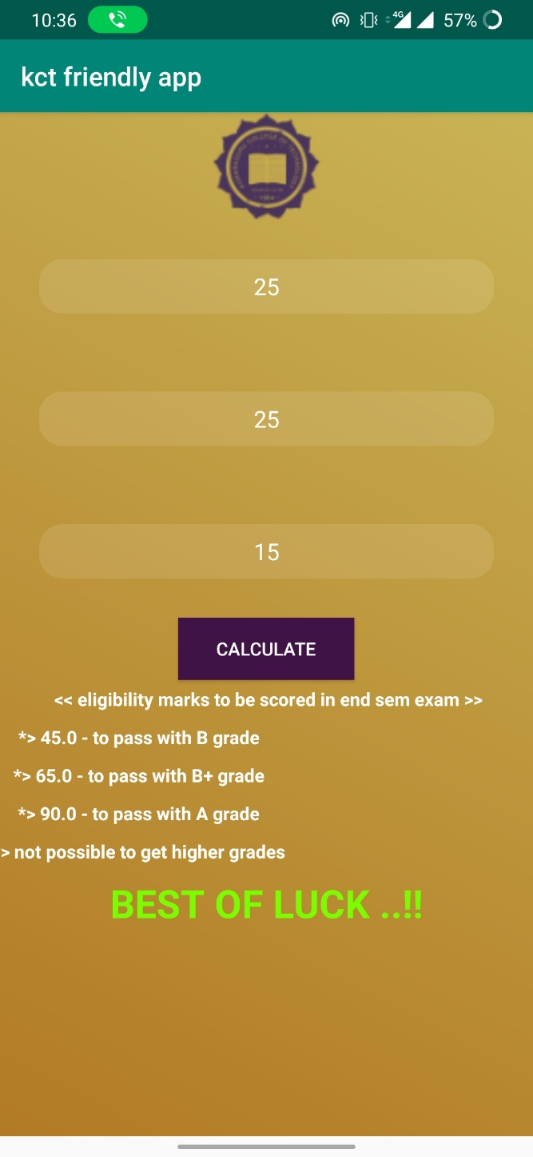

Figure 4.2: As user input is given, the output is displayed (Sample Output -1)

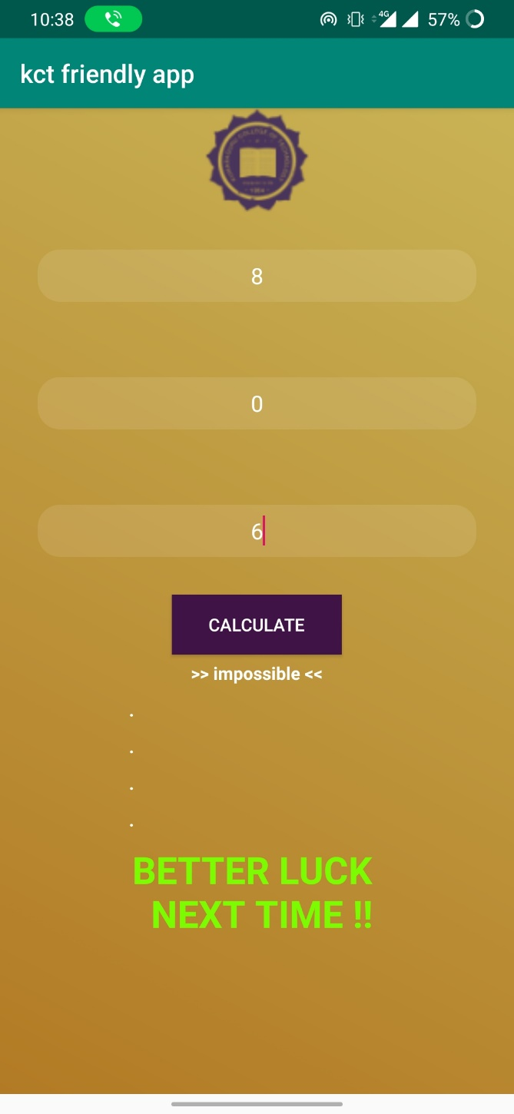

Figure 4.3: Sample Output -2

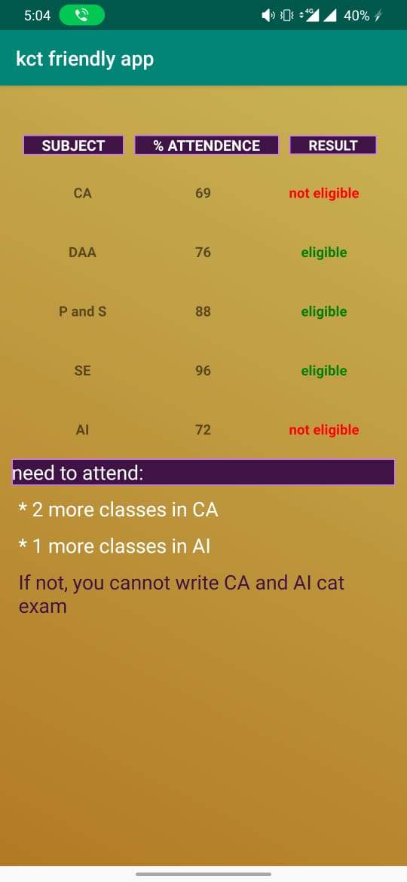

Figure 7 Attendance predictor Portal

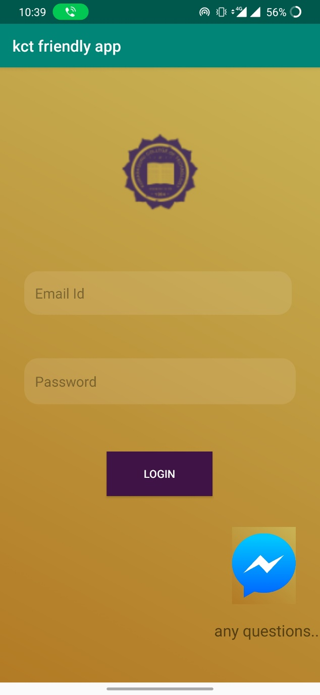

Figure 8 : Login Page with Help Center

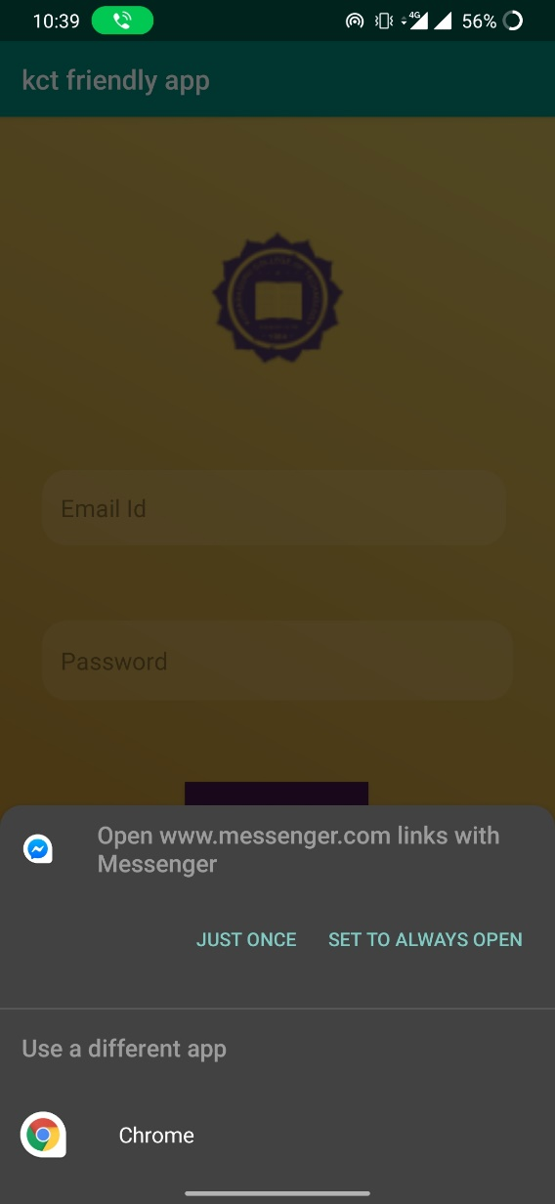

Figure 9 : Clicking Messenger button links it to the messenger application

:

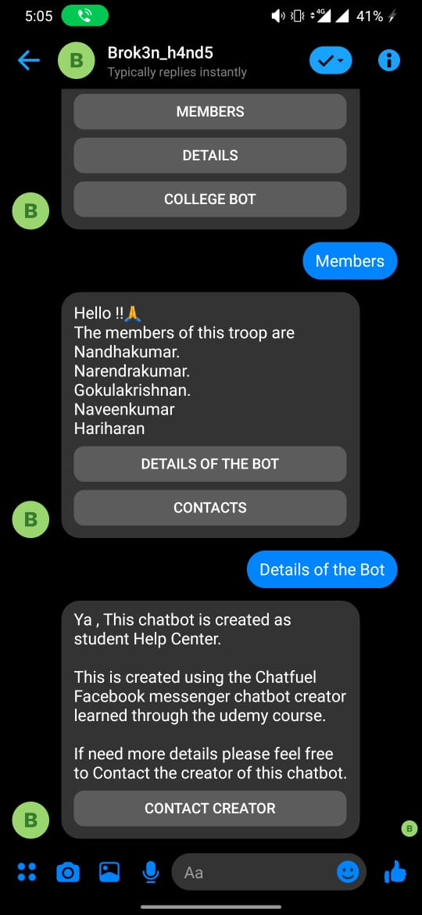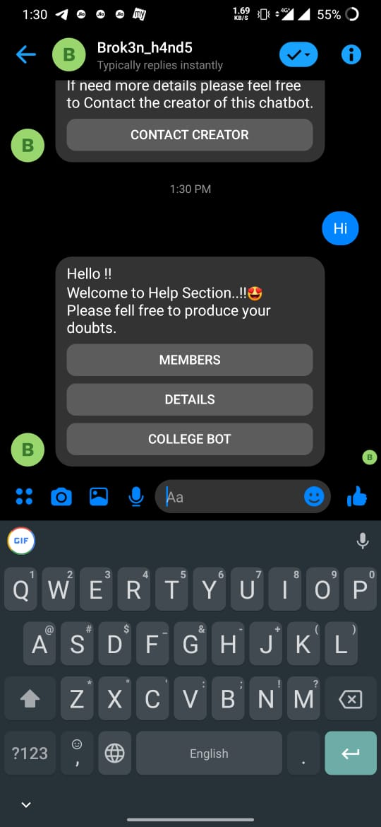

Figure 10.2:Charbot Sample 2

Figure 8.1: Chatbot Sample 1

7.Literature Survey:

There are already lots of portal or application for each college showing the statistics of the student prevailing in this world. But KCT Friendly App provides the apt data or the future required data obtained through simple calculations which is most needed for the student like us which no other application gives. This application is mainly inspired or can be correlated with the KCT Student App. This application shows the obtained marks of the student but not the mark to be obtained in the upcoming exam to score pass mark or a good grade. In addition, this application shows the prevailing attendance of the student but not the number of classes to be attended in the upcoming days to ensure the permissible percentage in order to write the next exam. Through our KCT Friendly Application we have brought up the new feature which are most essential in the hand of a student so that he/she may excel in the field of academics and extracurricular activities.

8.Results and Discussion:

All the above-mentioned preposition has been implemented and the corresponding workflow of login, signup, mark analyser, attendance predictor portal has been successfully verified and are working in perfect condition.

9.References:

* <https://firebase.google.com/>
* <https://developer.android.com/>
* <https://www.youtube.com/watch?v=qK0QNA0sMGc>
* <https://www.udemy.com/course/the-chatbot-bootcamp/>
* <https://www.udemy.com/course/the-android-developers-journey/>